Name | Arsh Raina
UID no. | 2021600053
Experiment No. | 7

AIM: | Implement various text processing problems.
Program 1
PROBLEM STATEMENT : | A men’s sports club keeps elaborate computerized records of all its members. The records contain typical information such as age, address, etc. of each person. But there is also information about whether a member is an active playing members, about whether he is married, and so on; if he is married the record contains information about his wife’s name, the no. of children and their names. Write a program which demonstrates how such a system might be implemented. Show how the names of the wives of all active playing members might be printed.
PROGRAM: | 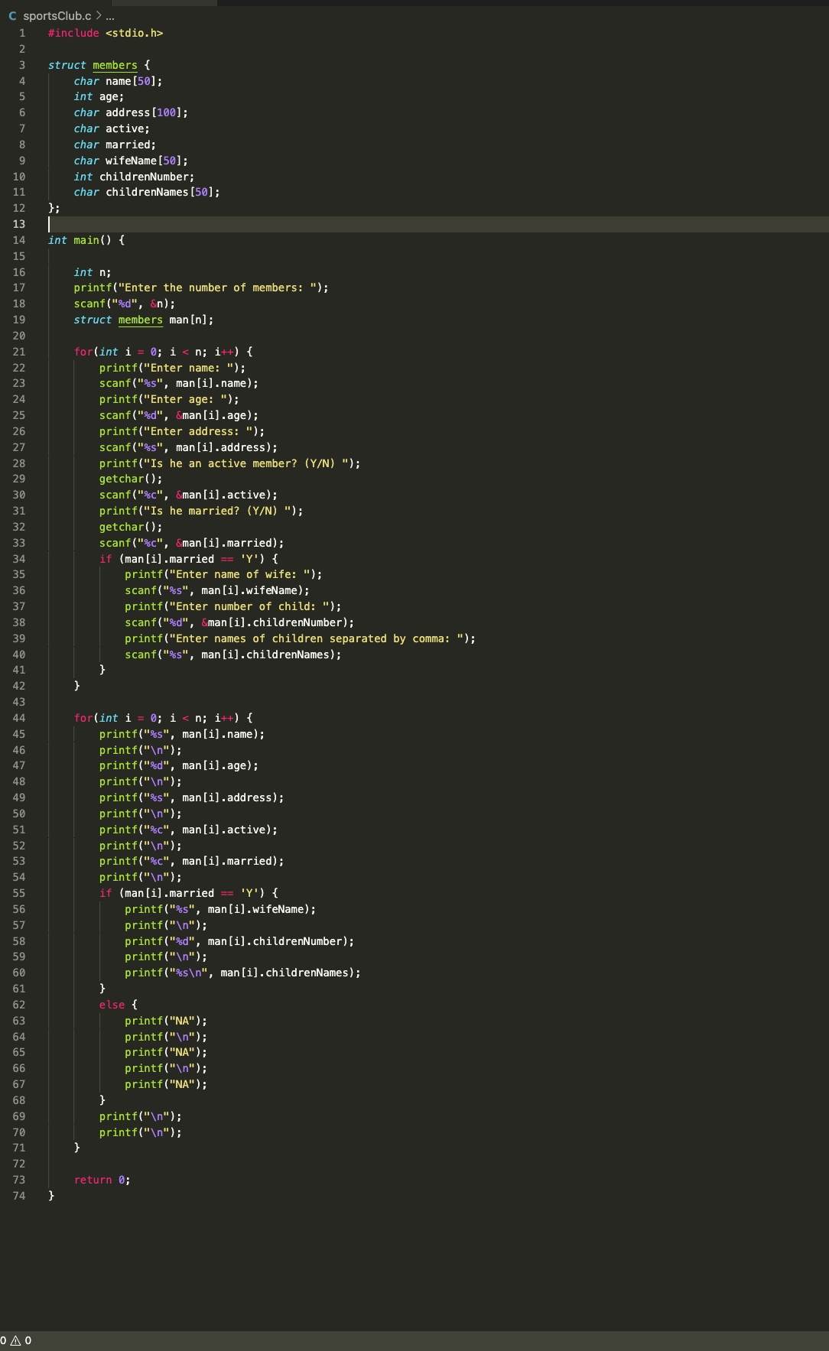
RESULT:
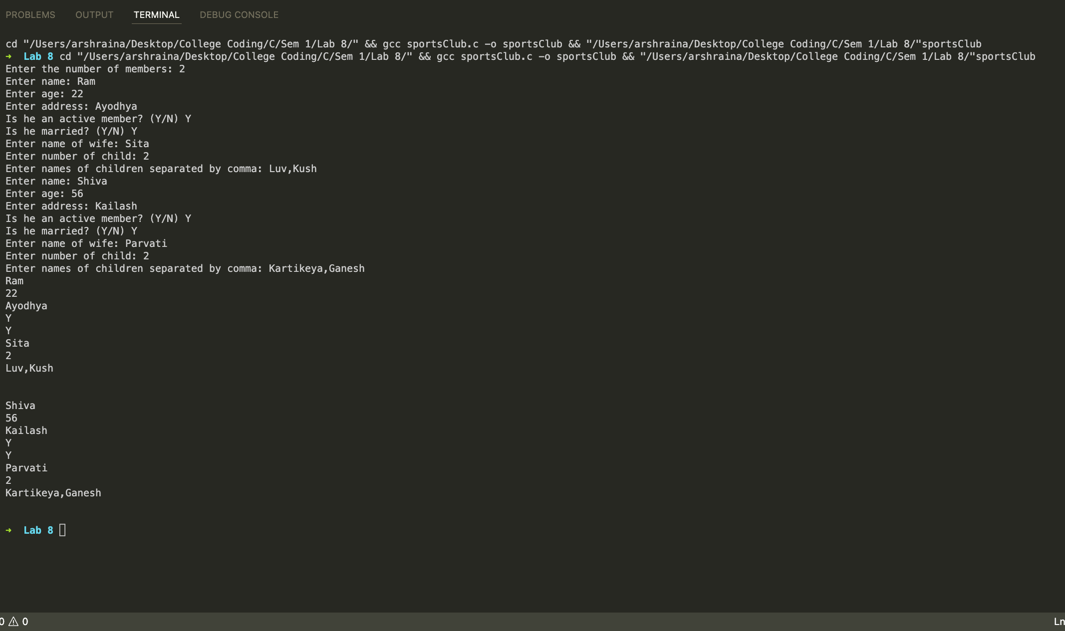
Program 2
PROBLEM STATEMENT : | An airline reservation system maintains records for possible flights consisting of STARTING POINT 3 character code DESTINATION 3 character code STARTING TIME integer on scale 0001 – 2400 ARRIVAL TIME integer on scale 0001 – 2400 SEATS positive integer in suitable range. Your program is to read 20 such records followed by queries of the form STARTING POINT– DESTINATION, one to a line. For each query find whether there is a possible flight with a seat available; if so reduce the number of seats by one and print out the flight details (or an apology).
ALGORITHM: | Step 1: Start  Step 2: Read the number of flights. Go to read_flights function  Step 3: Read the data of each flight using struct  Step 4: Go to book_flights function. Read number of queries from the user  Step 5: 0 <= i < n  Flag = 0  Read source and destination  If strcmp(src,f[j].sp)==0 && strcmp(des,f[j].dest)==0 or go to  Flag = 1  If f[j].seats>0. Print “congratulations”  Go to print function  Else print “Sorry”  Step 6: print “sorry”  Step 7: Print flight details  Step 8: End
PROGRAM: | 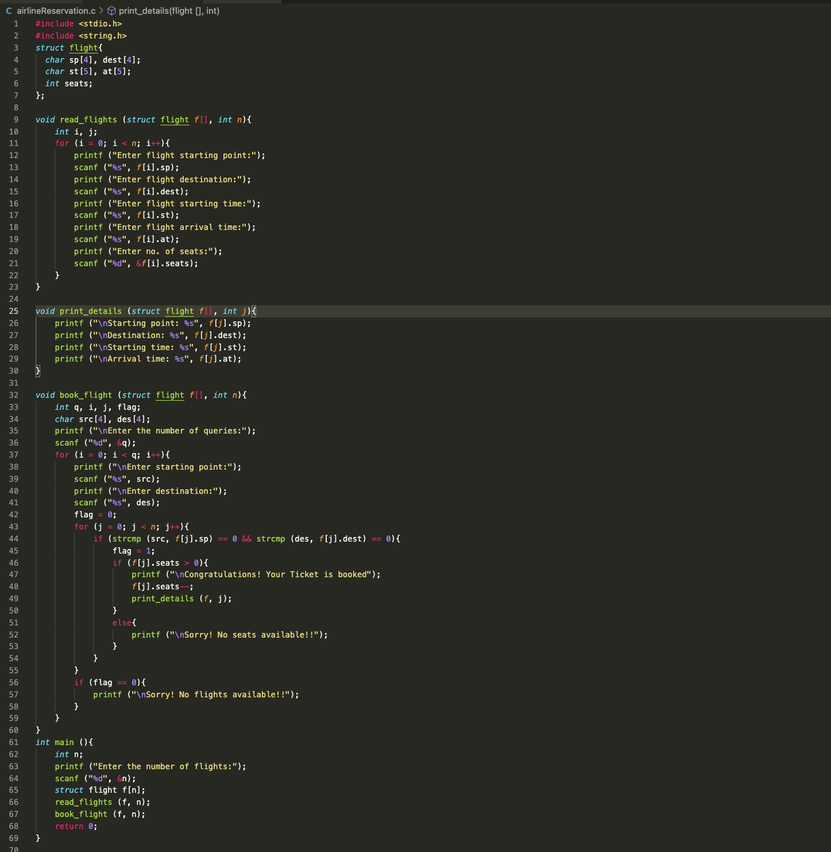
RESULT:
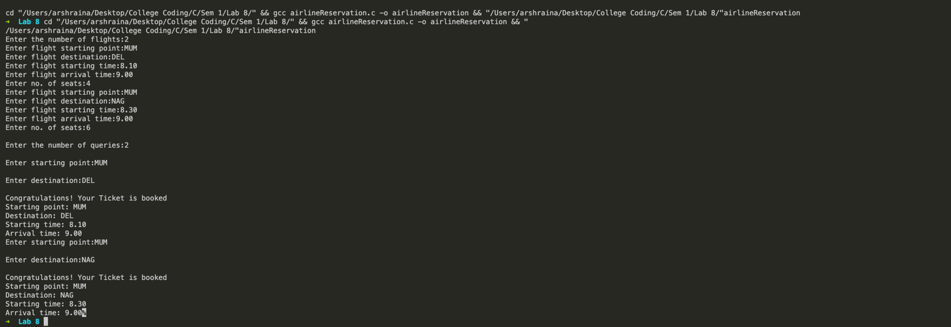
Program 3
PROBLEM STATEMENT: | A structure “Cricket” consisting of following: i) Player name ii) name of the country number of matches played iii) number of goals scored Make a programme to read records n players and to prepare list according to: i) players name ii) countries name iii) number of matches played iv) number of goal Scored
PROGRAM: | 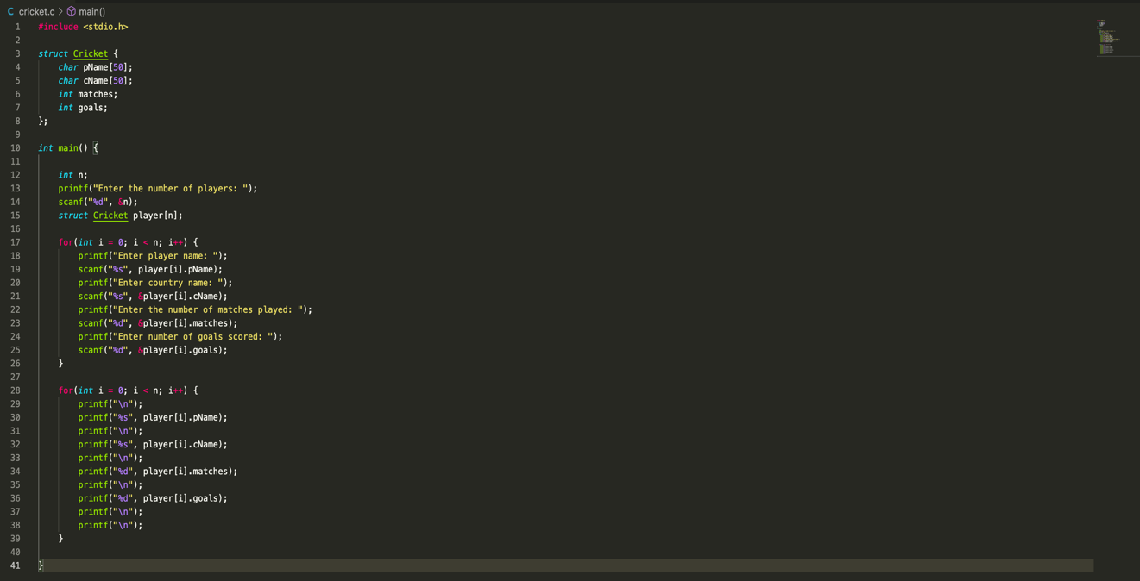
RESULT:
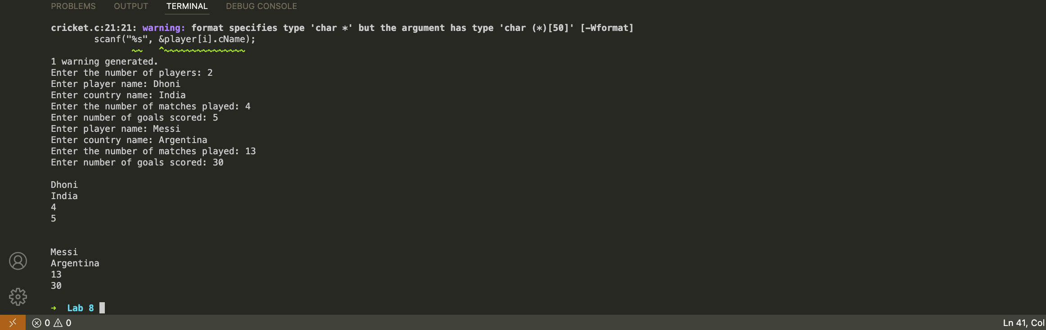
CONCLUSION: | Successfully implemented various text processing problems.

